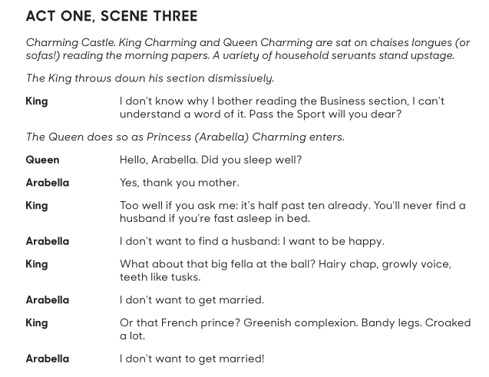

**Just practise the lines of The King and Arabella. One of the teachers will read the Queen’s line.**

Songs words for singing audition:

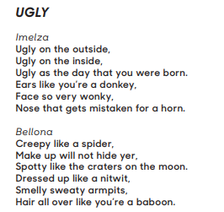

Music is on the school website to practise along with.