Knowledge Organiser for EYFS – Foundation Knowledge for Autumn 1

Literacy | Number
To answer a question using a full sentence,  To begin to hold a pencil in a tripod grip:  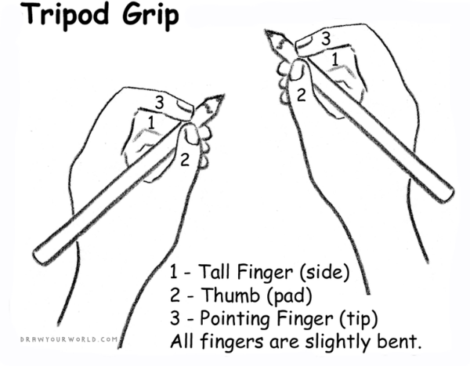  To use their left hand OR right hand consistently when writing and drawing.  To read and write their first name.  To hold a book correctly.  To know that English is read from top to bottom and left to right.  To show an interest in books.  To talk about their favourite story. | To know the numbers to 5  To recognise the numbers 0 – 5  To write the numbers 0 – 5 with the correct formation  To count out 5 objects accurately  To know one more and one less of each number to 5  To say the number of dots on a dice without counting  Please note:  In order to achieve the expected standard this half term, children must be confident in the areas in bold type.
Phonics | Topic & General Knowledge
To hear and say the first sound in a word e.g ‘d’ in ‘dog’.  To continue a rhyming string e.g ‘cat, sat, mat …’  To recognise, accurately pronounce and write all the Set 1 phonemes:  m a s d t i n p g o c k u b f e l h  sh r j v y w z x  Guidance on how to pronounce the `pure sounds` correctly can be found on the internet. There are several videos on Youtube if you search for `RWI Pure Sounds`. There is also guidance on the Oxford Owl website:  https://www.oxfordowl.co.uk/for-home/reading/phonics-made-easy/ | Time:  To know the days of the week  To begin to learn the months of the year  To know the month I was born  Shape:  To know and name the following 2d Shapes:  Square, circle, triangle, rectangle  Colour:  To recognise the following colours: red, yellow, blue, green, orange, brown, purple, pink, grey, black, white  Understanding the World:  To know the name of the village that I live in.  To know the name of my street.  To know the term ‘Autumn’ and describe what happens in the Autumn

