Cottenham Primary School
June 2022

June 2022

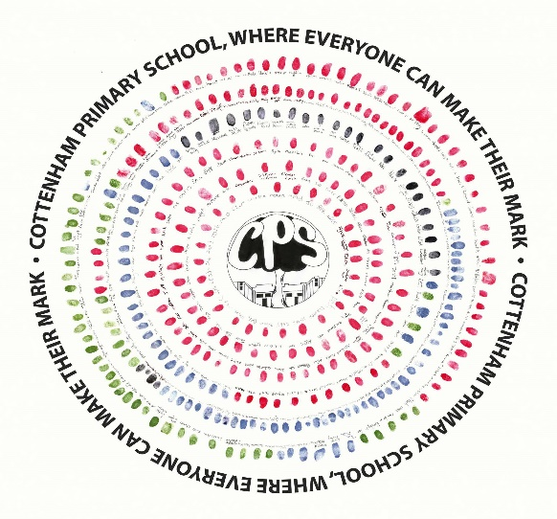
Registration Form for Voluntary Helpers

Registration Form for Voluntary Helpers with Disqualification Declaration and Risk Assessment for an Enhanced DBS Check
You will appreciate that the School must be particularly careful to enquire into the background of individuals who have access to pupils at the School. The School keeps a record of all persons who carry out voluntary work at the School. You are asked, therefore, to complete the details below and return them to the School. In accordance with Keeping Children Safe in Education, we ask volunteers to give names and addresses of two ‘professional’ referees. Please provide these below.
If, as a voluntary helper, you have regular unsupervised contact with the pupils then it will be necessary for a Disclosure and Barring Check, including a Barred List Check, to be made on you.
Title: | Choose an item.
Last name:
Previous name/s:
First name/s:
Email address:
Address:
National insurance number
Date of birth:
Telephone number:
Have you ever lived overseas? | Yes: ☐ (please give details separately) No: ☐
Relevant experience (e.g. education, training, employment or voluntary work)

Referees
Please give names and addresses of two potential referees who can comment on your suitability to work with children.
First Referee
Full name:
Job title:
Telephone number:
Email address:
Relationship to applicant:
Second Referee
Full name:
Job title:
Telephone number:
Email address:
Relationship to applicant:

Reference Declaration
In compliance with the General Data Protection Regulation (GDPR), we would like to ensure that you are aware of the data we will collect and process when requesting your references.
Reference requests sent to your referees will ask the referee to confirm as a minimum:
- The referee’s relationship with the candidate.
- Details of any substantiated allegations or concerns relating to the safety and welfare of children.
- Details of any child protection concerns, and if so, the outcome of any enquiry.
- Whether the referee has any reservations as to the candidate’s suitability to work with children. If so, the School will ask for specific details of the concerns and the reasons why the referee believes the candidate may be unsuitable to work with children.
By signing the below I consent to my named referees being contacted in accordance with the above.
Signature:
Print name:
Date:

DBS Check
It is the School’s policy to require all volunteers to disclose convictions or cautions (excluding youth cautions, reprimands or warnings) that are not ‘protected’ as defined by the Ministry of Justice.
In addition, the role that you are applying for is exempt from the provisions of the Rehabilitation of Offenders Act 1974 (Exceptions) Order 1975 (2013 and 2020) which requires you to disclose all spent convictions and cautions except those which are ‘protected’ under Police Act 1997 – Part V and the amendments to the Exceptions Order 1975 (2013 and 2020) and are not subject to disclosure to employers on DBS certificates and cannot be taken into account.
I consent to a Disclosure and Barring and Barred List Check being made on me if I will have regular unsupervised contact with pupils and to this form being held by the School as a record that appropriate checks have been carried out.
Signature:
Print name:
Date:

Disqualification
In accordance with the provisions of The Childcare Act 2006 and The Childcare (Disqualification) Regulations 2009 and Childcare (Early Years Provision Free of Charge) (Extended Entitlement) (Amendment) Regulations 2018, there is a requirement on some volunteers (including individuals on work experience) in educational settings to disclose relevant information. This requirement will apply to your application if the post you are applying for is in an Early Years setting with children (from birth until 1 September following a child’s fifth birthday) or Later Years childcare (children above reception age but who have not attained the age of 8) in nursery, primary or secondary school settings, or if you are directly concerned with the management of such childcare.
I confirm that I fall within the scope of the legislation and I am not disqualified from working with children in Early or Later Years settings (this covers children above reception age but who have not attained the age of 8). I understand and accept that I must inform the Headteacher immediately if I become disqualified.
Signature:
Print name:
Date:

For School Use – DBS Risk Assessment
(Section 1 or 2 must be completed)
Section 1: Regular unsupervised contact with pupils
Nature of work with children:
Information known about the volunteer:
(See above application form)
Has the volunteer undertaken any voluntary activities where references can advise on suitability to work with children?
Is the role eligible for an Enhanced DBS check with a barred list check? | Yes: ☐
DBS application made: | Yes: ☐
Date:
Signed:
DBS clearance received: | Yes: ☐
Date:
Signed:
Section 2: No Regular Unsupervised Contact with Pupils
Nature of work with children:
Information known about the volunteer:
(See above application form)
Has the volunteer undertaken any voluntary activities where references can advise on suitability to work with children?
Is the role eligible for an Enhanced DBS check without a barred list check? | Yes: ☐
No regular unsupervised contact with pupils: | Yes: ☐
Date:
Signed:

