What to do if you’re feeling…

I don’t understand my work and the adults are too busy to help me. This makes me feel stupid.
You are definitely not stupid! Remember at CPS we just want to see the ‘Best version of you.’ If the adult at home cannot help, maybe you could have a look on the school website, or ask an adult to contact your teacher. If not just move onto something else and come back to it later, don’t waste time worrying. Sometimes when you go back to something it makes more sense. If you still don’t understand, agree a time with your adult to help when they’re free.
I’m worrying about what to do if my parent’s or carers get sick? I’m worried about a family member who is in hospital with Covid-19.
Here is a useful website for any worries you have around Covid-19. Storicise
I miss my friends.
Maybe you could write your friend a letter or draw them a picture. You could post this through their door whist on your daily exercise. Think how excited you’d be to receive a letter from your friend!
I can’t sleep.
Sticking to a routine is really important. Begin your bedtime routine an hour before you’d like to fall asleep. Writing down any worries before you go to sleep can also help. You could make a worry box or give your worries to a worry monster or teddy. Find a time to talk through your worries with an adult the next day. Activities to include before bedtime could be a puzzle or colouring (no screens), a warm drink, hot bubbly bath and a book. You’ll find some useful resources at the end.

I’ve got too much work and I don’t know where to start. How will I know if I’ve done enough work?
Planning is key! Refer to the resources to find ‘My GREAT Planner.’
The adults at home don’t understand my work?
Remember to be kind to them, after all they are not teachers and are learning too. Why not work together to find some help and if you are still unsure, ask your teacher.
I’m worried about coming back to school.
Don’t worry that feeling is normal. If you have big feelings there will always be someone at school who can help. Remember CPS hasn’t changed, the systems we have to keep us safe will still be there.
I’m worried about how missing school will affect me when I move to secondary school.
The most important thing to remember is that this has happened to everyone. We will support you with everything you need.
I’m finding it hard to get started and concentrate on my work I don’t want to do it, I’m happy playing.
Taking regular breaks and rewarding yourself with something nice when you’ve finished may help you to focus and get the job done. Work for small amounts of time. It’s important to keep up with your learning so you don’t fall behind when you return.
I’m feeling angry about…
Remember that feeling angry is a perfectly normal emotion and that it’s what we do with that anger that’s important. There are lots of things you can do to help manage your anger. One thing is the importance of sharing how you feel with a trusted adult or friend. Writing down your feelings will also help. Maybe you could make a feelings diary or tracker to help understand what could be causing your anger. You’ll find some useful coping strategies at the end.
I’m feeling sad, anxious or scared.
There have been so many changes to our lives recently and so it’s perfectly normal to have these big feelings. Remember you won’t always feel this way. Letting someone know how you’re feeling is very important, don’t bottle them up. Also don’t forget that you’re not alone, you aren’t weird and most of all you are very brave.
Resources
Star Breathing
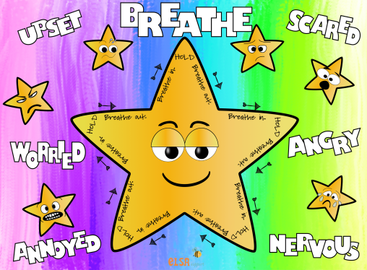
5’4’3’2’1
Look around and name five things you can see, five things you can hear, then start over and name four things (they could be the same). Now three things, continue with two things and lastly name one thing.
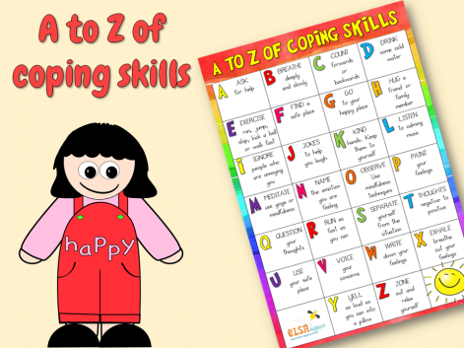

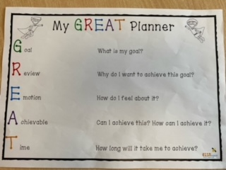
Worry Monster
Worry-Monster-Craftivity.pdf (elsa-support.co.uk)
worry-monster-poem.pdf (elsa-support.co.uk)

