Cottenham

Primary

School



Behaviour Policy

|  |  |
| --- | --- |
| Date: | Autumn 1 2024 |
| Reviewed by: | Standards |
| Next Review date | Autumn 1 2025 |
| Equality Review Checklist | In reviewing this policy due consideration must be given to the impact that changes may have on issues of equality for the protected groups:  **Age, Disability, Religion or belief, Race, Pregnancy and Maternity Sex, Sexual orientation, Gender reassignment Marriage/civil partnerships**  If the equality of a protected group is likely to be compromised by changes to the policy then please complete an equality risk assessment and tick here: |

**Cottenham Primary School**

**Behaviour Policy**

*(Please note: this policy is to be applied in conjunction with a number of other policies and documents across the School, including the CPS Framework of Expectations; CPS Anti-Bullying Policy; CPS Physical Intervention Policy; CPS Disability Policy; CPS SEND Policy; CPS Safeguarding Policy*

1. **The CPS View of Behaviour**

Children need to feel valued. It is when a child has good self-esteem that they learn best. Our behaviour strategy reflect this: we aim to create an environment which, through shared systems and strategies, leads to effective self-discipline and behaviour management and strives to protect and build the self-esteem of every child in our community.

We believe that children need to be taught what good behaviour looks like and that this needs to be modelled by the significant adults in their lives. We believe that all children are responsible for their own choice of behaviour and in most cases are able to modify it with support. We acknowledge that a child’s behaviour can be telling us something about them and we accept the need to support them to amend their behaviour so that they can appropriately access the school day and provisions. We know that in some cases it may not be possible to support a child to amend their behaviour to a level that we feel is appropriate and that external support may be required.

At Cottenham Primary School we are committed to providing the best possible education so that all our children thrive and achieve. We believe our children, families, staff and governors are of equal value and we respect and appreciate the diversity they bring to our school community. Through our policies and practice, we strive to foster positive relationships and a shared sense of belonging and we challenge any inequalities or barriers that exist. We welcome our duties under the Equality Act 2010 to eliminate discrimination, advance equality of opportunity and foster good relations.

1. **Consistency**

Consistency in managing behaviour is key. All staff need to know how to promote desirable behaviour, manage difficult or dangerous behaviour, and have an understanding about what that behaviour may be communicating. All staff should focus on de-escalation and preventative strategies rather than relying solely on reactive strategies.

At CPS we ensure this by having a robust Behaviour Policy and through the training of staff in alignment with the principles outlined the Cambridgeshire Therapeutic Thinking Approach, endorsed by Cambridgeshire County Council.

**Aims of Cambridgeshire Therapeutic Thinking Approach**

* develop a common language and joint approach that is followed by all professionals in Cambridgeshire, thereby supporting consistency within and across services.
* support schools and settings with developing a therapeutic approach to behaviour.
* improve staff confidence and safety.
* reduce suspensions and exclusions by considering more inclusive alternatives.

Staff are encouraged to support one another to manage behaviour and monitoring of behaviour management is regularly carried out by the Senior Leadership Team (SLT). The Inclusion Lead takes the lead in this area of work and cascades his training down to staff at all levels across the school.

All adults in school take responsibility for implementing the school values, rules and expectations. As adults walk around the school they will always aim to do the following:

* Frame positively when reminding children about behavioural expectations, e.g. ‘We walk because it’s safer’.
* Politely challenge a child who is in the school building at break/lunch times
* Deal with inappropriate behaviour directly, or seeking support to avoid significant escalation
* Discuss inappropriate behaviour with children and remind them of their obligations
* Intervene if children are talking to others in a disrespectful way
* Model and positively reinforce desirable behaviour
* Inform class teachers promptly of any inappropriate behaviour and how it has been dealt with, asking for support if necessary

Some children, including those with SEND, will require additional support to manage their behaviour and this may include alternative methods/strategies to those listed above. If this is the case, methods to address their behaviour will be outlined in an individual Risk Management Plan and will have been agreed and shared with parents, staff and the pupil as appropriate. Some children will have a behaviour focus on their Individual Learning Plan if they are also on the SEND register. Class teachers may devise and use specific personalised behaviour systems to support pupils meet the expectations, providing they are in line with the principles outlined in this policy.

1. **Definitions and Expectations of Pupil Behaviour at CPS**

The spine of this policy is the ‘Managing Behaviour at CPS’ document as outlined in section 4. It outlines the behaviours we expect from children and defines the rewards and consequences that may be used, which are ‘banded’ into groups through desirable, disruptive, difficult and dangerous.

It is essential that these expectations are regularly taught to children. This should occur in detail in the first week of each term and as often as necessary thereafter (including during whole school and team assemblies). Children need to see the rules being used consistently and fairly. We reflect with the children at regular intervals about how the rules are being implemented; this may be through class PSHCE lessons, Whole School Assemblies, House Days or discussions with individuals.

1. **Managing Behaviour at CPS**

These are the responses that the school will apply to pupil behaviour in most cases. In rare cases, pupils will need an individual plan to manage their behaviour. This may take the form of a Risk Management Plan, a Pastoral Support Plan or as part of an Education Health and Care Plan. These work alongside this document and offer additional advice about how to manage a pupil’s behaviour. The ‘Managing behaviour at CPS’ document outlines procedures for dealing with all common disruptive or difficult behaviours. This is not an exhaustive list and undesirable behaviours which aren’t on the list will be managed as the school deems appropriate, in line with the Behaviour Policy.

**Use of ‘Gold, Green, Yellow and Red’ faces to support a Therapeutic Approach to Behaviour Management Systems**

The four coloured faces form a foundation for teachers to manage behaviour in the classroom. All staff are to use the word ‘Warning’ as an initial opportunity for pupils to modify disruptive behaviours in the classroom or school environment. Teachers and support staff are to avoid publicly announcing or displaying the use of the yellow and red faces on classroom walls in front of peers. This supports the face system to be used effectively and in line with the approaches of Cambridgeshire Therapeutic thinking, particularly in relation to pupils who have poor self esteem, difficult forming relationships or may have experienced significant Adverse Childhood Experiences ( ACES – Appendix 10). This approach celebrates the desirable behaviours openly but does not draw public attention to pupils unable to meet the expectations. This reduces the potential opportunities for escalation of behaviour at the time and reduces the likelihood of inducing feelings of shame in pupils. It also minimises opportunities for undesirable behaviours to be used as an attention seeking mechanism in the classroom by pupils in front of their peers.

|  |  |  |
| --- | --- | --- |
| **Gold Face** | Used to reward exceptional desirable behaviours by pupils | Visible in classroom on wall. Teacher to use knowledge of pupil to decide if this is publicly shared with other students. |
| **Green Face** | Default status for all children in the morning and at the start of each session. | Displayed on classroom wall. |
| **Yellow Face** | Used following the issuing of a warning if disruptive behaviour continues. | Yellow face on teacher desk, not publicly displayed. Whiteboard pen/ name card used more discretely. |
| **Red Face** | Used for repeated disruptive behaviours or difficult and dangerous behaviour. | Red face on teacher desk, not publicly displayed. Whiteboard pen/name card used more discretely. |

* *In the Autumn Term, EYFS pupils will be taught about the school’s behaviour expectations and the principles of how the faces are used in the classroom. This will include the faces continuing to be on display on the wall for the first term.*

|  |  |
| --- | --- |
| **Behaviour** | **Response / Consequence to be used** |
| **Examples of desirable behaviour**   * Aiming high * Accepting challenge * Working together * Engaging in lessons * Listening well * Being kind * Looking after the school environment * Walking sensibly around the school building | **Response**  Desirable behaviours will be recognised and rewarded in line with the Behaviour Policy.  If behaviour is particularly outstanding parents may be contacted to share this.  Examples of desirable behaviour by pupils may be also shared at Parent Teacher Consultation evenings. |
| **Examples of disruptive behaviour**   * Shouting out in class * Distracting others * Negatively impacting on the learning of other pupils * Talking in class * Failure to follow reasonable instructions * Entering school building needlessly at break/lunchtime * Showing a lack of care for school property * Disengagement in class * Rude or disrespectful behaviour towards pupil, staff or visitors into school | **Response**  Managed by class teacher using Red, Amber, Green (RAG) faces:   * Pupils are given a verbal warning. * If the behaviour continues then their name is put on the yellow face; this will lead to missing 5 minutes of break time or lunchtime to reflect on their choices and actions. This may include completion of a ‘Reflection Sheet’ if appropriate as part of a reflective / restorative conversation with the teacher. * If the behaviour continues then pupils will receive another warning. * If the behaviour then continues the pupil’s name will be placed on the red face; this will be flagged with an SLT colleague and result in pupils missing part or all of their break or lunchtime. During this time the pupils will be engaged to discuss their behaviour choices, triggers and responses. They may also be asked to use a reflection sheet to record their responses themselves. The class teacher will record ‘ Red Face’ behaviour incidents on the My Concern platform and make contact with parents (either in person or on the phone) * Pupils will generally be expected to apologise, at an appropriate time if that is an appropriate response to the incident. * Children will be supported to understand the school’s high expectations for behaviour and given clear verbal guidance on what more appropriate responses could have been. * At end of each session, child MUST go back to green face   Reflection sheets, if used, will be kept by the class teacher. Class teachers will maintain a simple record of children who have reached yellow face sanctions each half term. ( Appendix 11) These will be collated by the Inclusion lead at the end of each half term for analysis. Teachers should feedback on a pupil’s behaviour at parent consultation evenings. The Inclusion Lead may suggest that parents are invited in for a specific meeting about a child’s behaviour if there are a high volume of incidents or there are no signs on improvements in disruptive behaviours. Example reflections sheets are in Appendix 6. |
| **Examples of difficult behaviour**   * Persistent disruptive behaviour (see box above for definitions) * Refusal to complete any class work * Kicking out (not directly at a person) * Throwing objects (not directed at someone) * Hitting out (not targeted at a particular person) * Shouting/screaming at others * Inappropriate or abusive language, * Damaging or destroying school property * Running out of class | **Response**   * These behaviours would result in the child being moved immediately to the Red face. This will be flagged with an SLT colleague and result in pupils missing part or all of their break or lunchtime. During this time the pupils will be engaged to discuss their behaviour choices, triggers and responses. They may also be asked to use a reflection sheet to record their responses themselves. The class teacher will record ‘ Red Face’ behaviour incidents on the My Concern platform and make contact with parents (either in person or on the phone) * Parents and carers will always be informed by the class teacher. * Key staff will be informed, including the Inclusion team, if further restorative provision is needed.   In all cases, SLT will consider the issues and details around the child and their behaviour and further responses and support will be identified, if appropriate. |
| **Examples of dangerous behaviours**   * Persistent difficult behaviour (see box above for definitions) * Spitting * Pinching * Head butting * Targeted hitting or kicking * Throwing objects at a person * Threat to use weapons * Use of weapons * Running away in public places * Damaging or destroying school property * Racist, sexist, homophobic or prejudicial language | **Response**  Often, dangerous behaviours, such as kicking or hitting out, appear without significant warning. When dangerous behaviours occur, it would not be appropriate to follow the warning system.  The safety of all members of the school community need to be paramount (including the child themselves) and any action needs to ensure this:   * The child should be immediately separated from other children and a member of the SLT needs to be informed and attend the situation. * Again, SLT will consider the issues and details around the child and their behaviour and further responses, including support, identified. The Inclusion team will be used to support and plan provisions around the child. * Due to the serious nature of the incident, the full range of consequences, including Fixed Term Suspensions (or the warning of), will be considered and applied as needed. * Dangerous behaviours will always be logged by the class teacher or SLT member on the MyConcern platform. Racist and homophobic incidents will also be recorded by the Inclusion lead on the Prejudice Reporting for Education site. |

1. **Rewarding desirable behaviour**

Cottenham Primary School rewards desirable behaviours in a variety of ways.

House Points are used as the primary method to reward positive behaviour and effort levels. The school is divided into 4 Houses and children are in the same House as their siblings. Children are encouraged to take pride in their House, which in turn promotes a sense of belonging. House Points can be awarded by any adult in the school and build toward the House totals for the week. Children may receive 1, 5 or, in rare cases, 10 House Points. All classrooms have a display for children to attach their House Points to. Year 6 pupils are involved in collating and reporting back on house point totals each week.

As part of the traffic light faces system, every classroom has a Gold Face, where children who have exhibited exemplary behaviour will be placed. Children who manage to achieve this will also be awarded with 5 house points.

The Senior Leadership team are to be proactively used to support the promotion of desirable behaviours and academic related achievements. Staff may send children whom they feel deserve such attention to SLT. SLT will issue merit stickers linked to the school values and may contact parents through email, phone or a postcard home to celebrate these successes.

A weekly Celebration Assembly updates the children on how many points each House has achieved and which House has won the House Cup for that week. At this Assembly, one or two children per class will also be celebrated with a certificate for exhibiting exemplary attitudes and behaviour. A theme for each week will be announced at Monday Assembly by the Head Teacher and will reflect our aims and values.

In Year 6, children can build evidence of positive behaviours and deeds to work toward attaining a SHINE Bronze Award. The award is designed to epitomise the values and behaviours that Cottenham Primary School wishes to promote. Children will receive 10 House Points for each aspect of the award that they are able to evidence and a further 10 House Points and a SHINE badge once they have achieved all 5 aspects of the award. The 5 aspects of the SHINE Award are:

* Succeed
* Help Others
* Inspire
* Never Give Up
* Engage

There will also be occasional whole-school initiatives to promote the school’s curriculum aims and values. These will also be shared and celebrated through assemblies and displays, and will contribute to the weekly House Point total.

In some cases, children may need additional motivation to improve their behaviour. This may be due to Social, Emotional and Mental Health (SEMH) needs or due to a different Special Educational Need (SEN) that means their understanding needs to be scaffolded further. This can take a variety of forms and will be documented in individual paperwork for that child, such as an Individual Education Plan, a Risk Management Plan, Pastoral Support Plan or their Education, Health and Care Plan.

1. **De-escalation and preventative strategies**

In all cases, the school’s first aim is always to prevent undesirable behaviour and to de-escalate behaviour when it begins.

All teachers, teaching assistants and leadership staff receive cascaded training in line with The Cambridgeshire Therapeutic Thinking Approach. The Inclusion Lead is trained as a trainer of this approach and is available to be a source of advice and support to others when dealing with difficult or dangerous behaviours.

Part of preventing difficult or dangerous behaviour is understanding why it is happening, and often this can be achieved through discussion with children. If behaviour is persistent then a variety of tools may be used to support identification, including a weekly monitoring ‘RAG’ form or Anxiety Map to track behaviour across a day or week. An Antecedent/Behaviour/Consequence (ABC) form may be used to further analyse the trigger for a particular behaviour. Use of these forms is rare and only when behaviour is persistently difficult or dangerous.

As well as giving a consistent approach to the de-escalation of behaviour, staff are able to access ‘scripts’ to guide their interactions with pupils.

Further advice on ‘guiding children’, if necessary, is available in the ‘CPS Physical Intervention Policy’. This policy is updated annually, considering any changes in Cambridgeshire policy and practice.

Staff are supported with guidance in Appendix 7, 8 and 9

1. **Agreed procedures for addressing disruptive or difficult behaviour**

The ‘Managing behaviour at CPS’ information in section 4 outlines procedures for dealing with all common disruptive or difficult behaviours. This is not an exhaustive list and any undesirable behaviours will be managed as the School deems appropriate, in line with this policy.

During lunchtime, the school provide two trained TAs as ‘Worry Busters’ to support de-escalation and prevention of difficult or dangerous behaviour. Incidents occurring during lunchtime are dealt with quickly and effectively by the ‘Worry Busters’, thus ensuring that the afternoon’s learning can begin promptly. When necessary, follow up work may be handled by the Class Teacher or a member of the Senior Leadership Team.

Year 6 pupils are also trained as ‘Peer Mediators’ and are on duty at lunchtime to support children in managing their own difficulties or disagreements at lunchtimes. They are supported by the Worry Busting staff and overseen by the Inclusion Lead.

Individual circumstances are always taken into account, as is the frequency and duration of a behaviour, when deciding on an appropriate consequence.

1. **Agreed procedures for addressing dangerous or persistently difficult behaviour**

Responses to dangerous or persistently difficult behaviour are outlined on the ‘Managing Behaviour at CPS’ information in section 4.

If a child’s behaviour is dangerous or persistently difficult, a Fixed Term Suspension (Previous term used is Exclusion) may be considered. This decision will only be taken in response to a serious breach, or persistent breaches, of this policy and where allowing the pupil to remain in school would seriously harm the education or welfare of the pupil themselves, other children or others in the School. Except in extreme circumstances, a Suspension Warning letter will be issued to parents during the escalation of behaviour, and parents will be invited to work with school staff to devise a plan to address the persistent difficult and dangerous behaviours. This may take the form of a Risk Management Plan, or a Pastoral Support Plan. These work alongside this document and offer additional advice and support about how to manage a pupil’s behaviour. Internal suspensions can also be used by the leadership team to support a child’s continued attendance at school but minimise the disruption to other children’s learning in classrooms.

If a pupil is displaying difficult or dangerous behaviour then staff may need to physically intervene. Further information on this is outlined in the CPS Physical Intervention Policy.

1. **Agreed procedures for addressing unacceptable behaviour by parents or visitors**

As a provider of education, we endeavour to foster a close working relationship with the wider community as we believe that it benefits the young people in our care. We particularly welcome parental/community contact with the school as we believe that working with parents and the community provides the strongest educational experience for our children.

Visitors to the school are required to adhere to the same code of values outlined in this policy, and to be aware that any threatening behaviour, verbal or physical, directed towards any member of the School community is completely unacceptable, and will not be tolerated.

Any member of staff who feels that a visitor to the school site is in breach of this guidance has the right to request that the visitor leaves the premises. In such situations a member of staff should report the situation, or request assistance from a senior colleague, at the earliest opportunity. The senior colleague will review the context of the situation and will base any decisions or further action accordingly.

**Appendices**

1. Blank Risk Management Plan (RMP)
2. Blank Pastoral Support Plan (PSP)
3. Blank ‘RAG’ behaviour monitoring form
4. Blank anxiety map
5. Blank Antecedent/Behaviour/Consequence (ABC) form
6. Blank reflection sheets examples
7. Example of de-escalation script
8. Example of de-escalation sentence starters
9. Examples of restorative conversation questions
10. Adverse Childhood Experiences
11. Disruptive behaviour class tracking sheet.

**Appendix 1: Blank Risk Management Plan Template – Used to identify behaviours and support staff to apply consistent response and strategies**

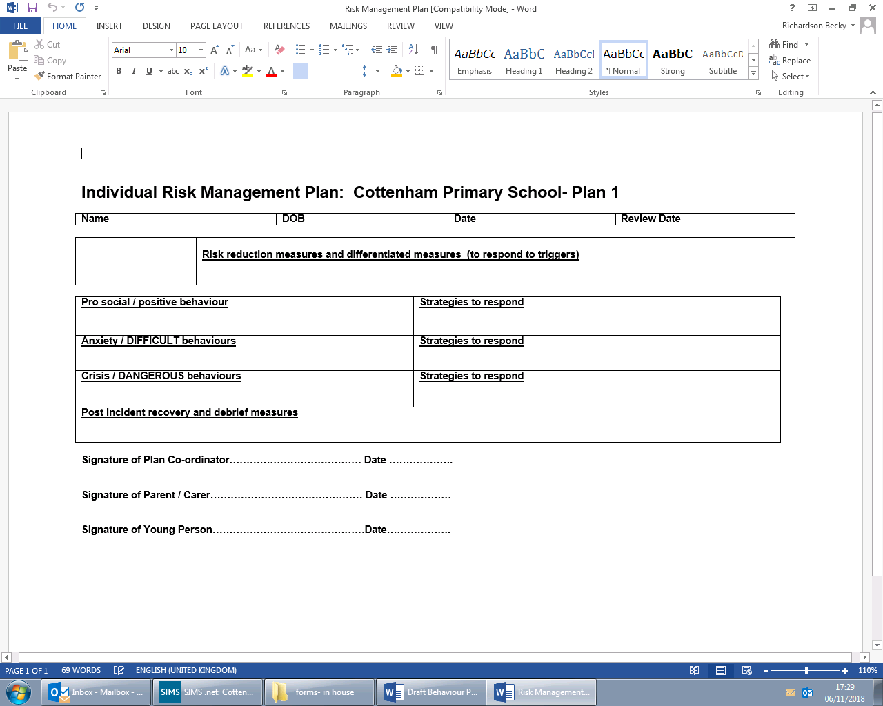

**Appendix 2: Blank Pastoral Support Plan (PSP)**

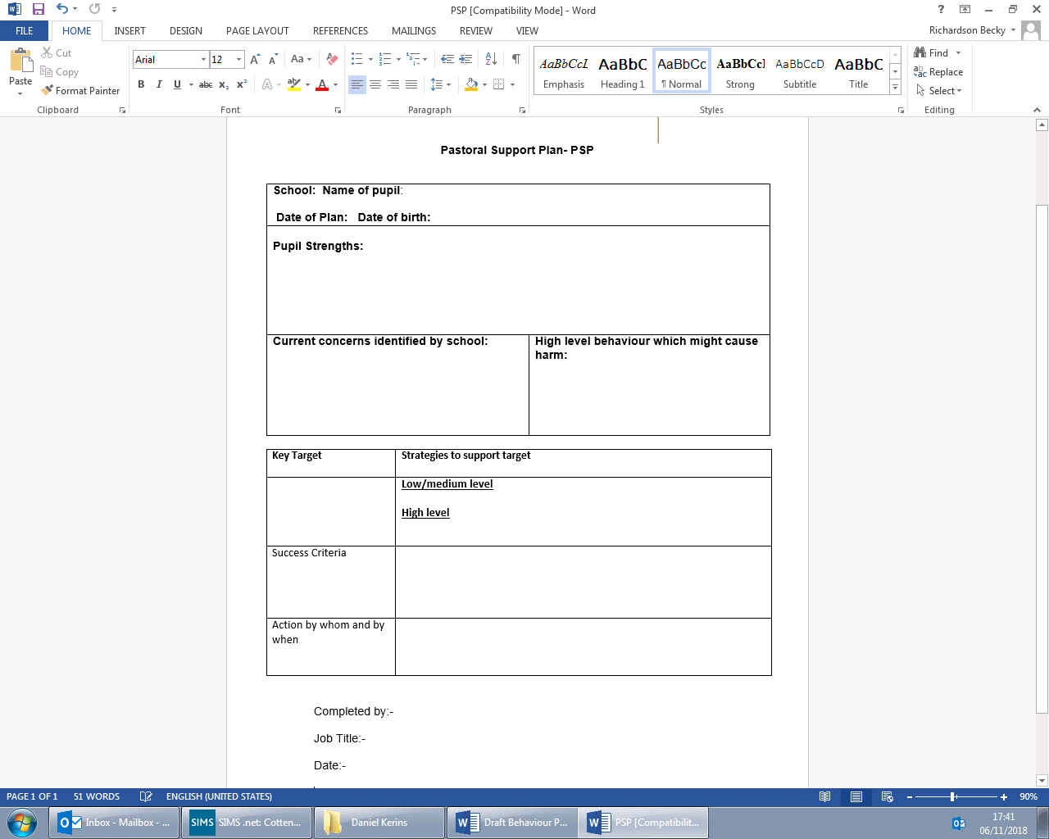

**Appendix 3: Example of ‘RAG’ behaviour monitoring form – Used to track desirable and undesirable behaviours over a week**

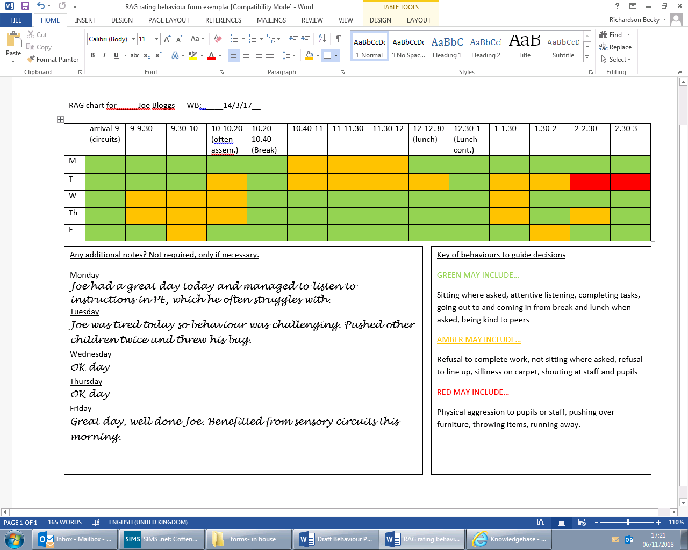

**Appendix 4: Blank Anxiety map – Used to identify triggers and patterns for behaviour**

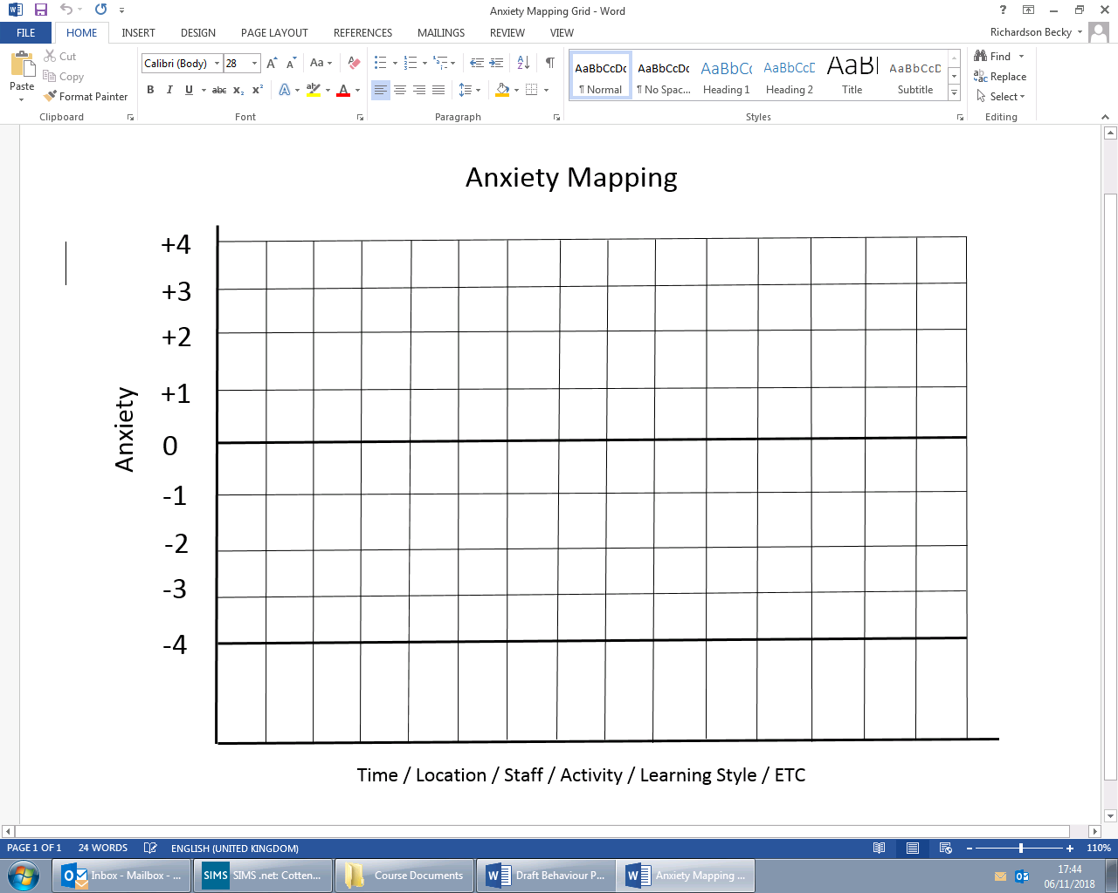

**Appendix 5: Blank Antecedent/Behaviour/Consequence (ABC) form – Used to log dangerous behaviour incidents**

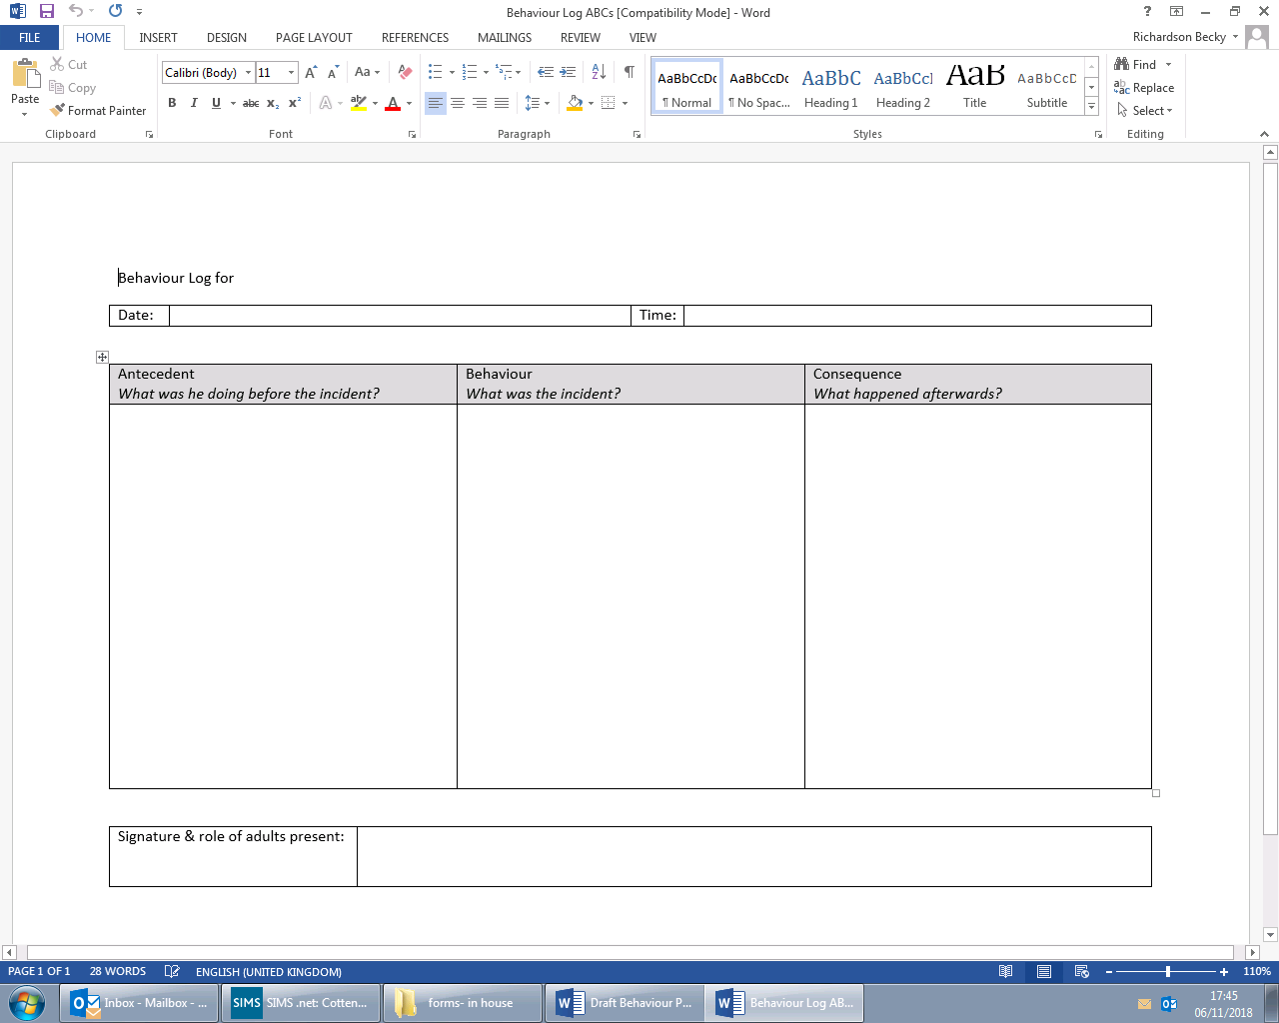

**Appendix 6: Blank reflection/ restorative conversation sheet templates – staff to use as appropriate for age, stage and development level**

**Appendix 7: De-escalation strategies - Used to support staff in de-escalating situations when talking to pupils about their behaviour -particularly if a child is already dysregulated**

1. **Stay Calm**: Maintain a composed demeanor. Your calmness can help soothe the child.
2. **Use a Soft Tone**: Speak in a gentle, reassuring voice to reduce tension.
3. **Acknowledge Feelings**: Validate their emotions by saying things like, “I can see you’re upset.”
4. **Give Space**: Sometimes stepping back can allow the child to cool down.
5. **Use Distraction**: Redirect their attention to something positive or engaging.
6. **Set Clear Boundaries**: Remind them of the rules calmly and clearly.
7. **Offer Choices**: Empower them by giving options within acceptable limits.
8. **Use Humor**: A light-hearted comment can sometimes diffuse a tense situation.
9. **Be Empathetic**: Try to understand their perspective and show that you care.
10. **Practice Active Listening**: Encourage them to express their feelings and listen without interrupting.
11. **Model Behavior**: Demonstrate calmness and self-control for them to emulate.
12. **Use Positive Reinforcement**: Praise good behavior when it occurs to encourage more of it.
13. **Engage in Breathing Exercises**: Teach them simple breathing techniques to help calm down.
14. **Set a Routine**: Consistency can help reduce anxiety and unexpected outbursts.
15. **Create a Calm Environment**: If possible, move to a quieter space to help them settle.
16. **Limit Stimuli**: Reduce loud noises or distractions that may be overwhelming.
17. **Focus on Solutions**: Encourage problem-solving rather than dwelling on the conflict.
18. **Take a Break Together**: Sometimes a short break can help reset emotions.
19. **Follow Up Later**: Once things have calmed down, revisit the situation to discuss feelings and solutions.

**Appendix 8: De-escalation sentence starters – used by staff in conversations with pupils - particularly if a child is already dysregulated**

* "I can see that you’re really upset right now; let’s take a moment to breathe."
* "It sounds like you’re feeling frustrated; can you tell me more about it?"
* "I understand that this is really hard for you; how can I help?"
* "Let’s pause for a second and think about what we can do next."
* "It’s okay to feel this way; let’s find a way to calm down together."
* "I’m here for you; let’s talk about what’s bothering you."
* "What if we tried to do something fun to help change how we’re feeling?"
* "I hear you, and I want to understand; can you explain what happened?"
* "Let’s take a deep breath together; it might help us feel better."
* "I know this is tough; would you like to take a break for a moment?"

**Appendix 9**

Examples of restorative conversation questions to be used by staff when talking with pupils. These can be adjusted as appropriate for age, stage and development level.

1. **Can you tell me what happened?**
   * What do you remember about the situation?
2. **How did you feel during that moment?**
   * What feelings were you experiencing?
3. **What were you thinking when it happened?**
   * What was on your mind at that time?
4. **How did this affect you, other children or your friends?**
   * Did it change how you feel about anyone?
5. **What do you wish had happened instead?**
   * How would you have liked things to go?
6. **What can we do to make things better?**
   * Is there something that would help you feel better?
7. **What can we do differently next time?**
   * How can we prevent this from happening again?
8. **How can I help you?**
   * Is there something specific you need from me?
9. **What can we do together to fix this?**
   * Can we think of a solution as a team?
10. **What did you learn from this experience?**
    * Is there anything new you understand now?

**Appendix 10: Adverse Childhood Experiences**

**Appendix 11: Tracking repeated disruptive behaviour**

